

Toolkit 2023

Please decide at what level you meet the criteria and then fill in the school evidence box with as much evidence as you see fit to prove that you meet the standard. The guidance and possible evidence box is there to help you, but if you feel there are other ways you can show it then please do include them too. Reference any appendices and attach them to the email.
We have a manageable and appropriate workload
FULLY MET / PARTIALLY MET / DEVELOPING
GUIDANCE  Is appropriate PPA time given?  Are staff meetings and briefings for an appropriate amount of time?  Is time provided for leading core subjects or other areas of responsibility?  Is workload appropriate for the job description?  Do staff feel able to have a homelife with time for relaxing? | POSSIBLE EVIDENCE  Examples of release and duty timetables  Use of HLTA’s  Staff meeting timetables  Survey data | SCHOOL EVIDENCE  - Timetables for PPA and release time are scheduled and timetabled with the appropriate cover planned for. This is shared in advance for all to see. (Appendix 1)  - PPA staff are internal staff (i.e. no use of external coaches) which means they receive quality CPD and deliver high-quality provision, which reduces the workload pressure for staff released (as they do not have to worry about the curriculum for their class). PPA staff make an active contribution to the quality of the overall curriculum. HLTA’s and designated staff cover PPA across the school.  - All teaching staff have 10% allowance of PPA weekly together with year group partners. PPA time is equal for all, regardless of role (part time / full time). This is recognised and highlighted within our Wellbeing Charter. (Appendix 2)  - The school has looked at opportunities for staff to receive additional leadership time in order to support workload demands, e.g. TLRs had extra time around appraisal reviews due to the time those take. TLR leaders have an additional 10% time weekly as a minimum along with the appropriate additional time for ECTs.  - Effective use has been made of the recovery premium and school led tutoring money to provide additional staff to support teaching across the school.  - All leaders have quality 121 time with the headteacher on a regular basis. This is scheduled within the school day, in addition to any leadership allocation they are given, to support their leadership work. (Appendix 3)  - We have a large workroom with staff library, access to copiers etc to ensure that PPA can be purposeful. All classrooms have desktop machines so that laptops are not needed in class when staff are on PPA time. The workroom has also had desktop machines installed but all staff (inc. TAs) have individual access to laptop devices to support their own workload. (Appendix 4)  - Staff meetings take place once a week every Wednesday 3.30-4.30pm to support manageable and appropriate workload. There are occasions, e.g. around report writing time, where staff meetings are allocated as directed time to support additional tasks.  - Twilights have also taken place this year to release staff early on an INSET day (which ran into half term) in order to support well-being.  - Short staff briefings take place every Friday morning before the start of the school day. This is to share key events / information / dates / AOB. Wellbeing forum feedback have had members comment on how valuable these are to communication in a large school.  - Survey data from Nourish Ed shows:  - 97.7% of staff asked, said they had a clear job description.  - 86.4% of staff asked, felt that the work they do reflects matches their job description and contract.  - An average of 8.4 was given when staff were asked if the school works towards embodying ‘whole school wellbeing’.  - An average of 7.6 say workload is manageable (which is in line with last year).  - Workload is constantly under review and is regularly discussed with SLT and also a standing agenda item within Governing Body meetings.  - Regular wellbeing forums continue to meet to consider strategies to support workload and wellbeing.

We value and prioritise staff’s health and understand the need to rest and recharge.
FULLY MET / PARTIALLY MET / DEVELOPING
GUIDANCE  Do you have quality facilities for all staff to eat at lunchtimes?  - Is there enough cutlery?  - Is there enough equipment? (Microwaves, stoves etc)  - Are there appropriate tables and chairs to eat effectively?  - Are there a different choice of seats to sit on?  - Do staff get subsided school meals?  Is your staffroom welcoming?  Do you provide refreshments free of charge?  Are there enough toilet facilities for all the staff?  Do staff feel able to ‘take a break’ at lunchtime as their workload allows it? | POSSIBLE EVIDENCE  Photographs  Staff testimonials  Staff survey data  Site plan | SCHOOL EVIDENCE  - Lunch is currently staggered, meaning there are not long queues to use equipment. Also staff who may not work together, have the opportunity to catch up and socialise.  - Facilities: Staff room has 2 microwaves, kettle, zip boiler, toaster, fridge, freezer, hot drinks vending machine, water machine, a radio, a weighing scale and table and chairs. There are also soft, cushioned chairs, allowing staff to relax and eat in comfort. Sufficient cutlery/cups/plates/bowls are available and are regularly replenished. (Appendix 5)  - Water cooler is free of charge, vending machine is a small charge of 25p (cost to break even).  - The staff room is well maintained and looked after.  - Staffroom has shared and meaningful inspirational quotes.  - Green Block (separate building) also has separate kitchen facilities available.  - Senior staff undertake lunch duties once per week. A Free lunch is provided for them by our catering company. Staff can also order paid hot meals through the School Grid app.  - Tuck Shop provision has been running for a year. However, this is also available for staff to purchase. Free fruit is always regularly available.  - Toilets - There are staff toilets dotted around each area of the building, all within a short distance. (Appendix 6)  - We also have a staff shower if anybody ever wanted to use it!  - Thank you messages from parents/carers are displayed in the staffroom and celebrated in staff briefings.  - We provide FREE breakfast items for staff. There is also help available to provided food for staff (as we do with parents/carers) if they needed it.  - Mental health/counselling is available FREE OF CHARGE to staff either in person or via Education Support Partnership. The ESP also provides other support, e.g. financial advice etc.  - Survey data from Nourish Ed shows:  - Average 7.9 say they have somewhere to go for a break.  - Average 8.6 say the staffroom is welcoming.  - Average 9.4 say the staffroom is well equipped.  - Staff are regularly reminded about the importance of taking a break for lunch / drink.  - In order to encourage staff eating together, we have 2 – 3 staff shared breakfast opportunities a year. Sometimes, these involve everybody bringing in items to share together. Sometimes these are catered breakfast from catering company ‘Dolcie’, that is FREE for staff.  - During in person parents evening, FREE refreshments are provided for all staff (as well as visiting parents/children) intermittently throughout the day / evening.

We have a member of staff in charge of wellbeing who is not on SLT
FULLY MET / PARTIALLY MET / DEVELOPING
GUIDANCE  Is the role set out as part of a job description?  How does the Wellbeing Lead feed back to SLT?  Is there a Staff Wellbeing Working Party (or similar) and who sits on it? | POSSIBLE EVIDENCE  Job descriptions  Staff survey data | SCHOOL EVIDENCE  - Yes, the member of staff in charge of Wellbeing is not a member of SLT.  - The role is not set out as part of a specific job description. However, all teachers job descriptions have an aspect of contribution to the wider development of the school. Within the staffing structure there is a leadership role for wellbeing clearly defined and noted.  - Designated leadership time is provided for wellbeing, as well as regular feedback from HT/ SLT/ Staff to support the role and help the schools wellbeing to thrive.  - The wellbeing lead communicates with the HT before forums to discuss agendas / acute topics for discussion and after wellbeing forums to feedback / discuss any issues and solutions. Emails are also sent to the HT regularly.  - Nourish Ed survey is undertaken as well as any specific workload reviews, to gauge the views of staff about workload and wellbeing related issues.  - Wellbeing is visible with school.  - Regular wellbeing forums are held. These are planned out at the beginning of term and shared in the school diary. All staff are welcome and encouraged to attend. Agendas are sent out via email in advance. (Appendix 7). Positivity and openness are actively encouraged.  - A Wellbeing Charter has been developed and shared with all staff and governors. It is displayed for all to see in numerous places within the school building. It is also included within or FGB pack. (Appendix 2).

Wellbeing is covered in CPD sessions 3 times a year
FULLY MET / PARTIALLY MET / DEVELOPING
GUIDANCE  Is wellbeing CPD available to all staff?  Are practical wellbeing strategies introduced?  Is health advice incorporated into CPD? | POSSIBLE EVIDENCE  Staff meeting agendas  Training timetables  Staff testimonials | SCHOOL EVIDENCE  - The wellbeing leader organises staff social events and activities. This has included staff bingo, murder mystery evenings, Dunelm ‘Delivering Joy’ incentive, delivered lunch for parents evenings, coffee van onsite for staff meeting days. (Appendix 8).  - Staff also get together regularly for out of school social events.  - During the Christmas period, free festive treats are provided as well as music to give a feeling of togetherness, whilst staff stay to decorate classrooms and communal areas together.  - The CPD schedule also includes opportunities for wellbeing within the school, e.g. INSET day lunch off-site, staff summer event (using school wellbeing budget) with free food and entertainment for staff.  - Secret Angels initiative continues with staff nominated to look out for the wellbeing of others.  - Well-being forums are organised every half term. Agendas are prepared to inform the well-being forums.  - Wellbeing and mindfulness CPD sessions have been planned previously.  - Staff celebrations: Birthdays are celebrated by giving birthday cards each year, shouts outs in briefings, golden staff nominations occur every half term and messages are shared with staff. Winners are celebrated on the wellbeing display and all nominees receive a treat whilst the winner wins a paid day of leave.  - Information, resources, links and health advice are available for staff to support their well-being on the school website. https://www.yewtreeprimary.co.uk/well-being-2/ JB also offers advice weekly in briefings.  - Supervision is also in place for the HT and the DSLs. This has also been extended last year to include members of the ECM team who feel they would benefit from this.

We operate flexible working strategies
FULLY MET / PARTIALLY MET / DEVELOPING
GUIDANCE  Is there flexible access to school during the holidays?  Is PPA allowed to be taken at home?  Does your school offer part time and job share contracts when available?  Are staff allowed (within reason) to attend their own children’s school events?  Does your email policy allow people to work at a time that suits them without disturbing others? | POSSIBLE EVIDENCE  Staff testimonials  Staff survey data  Staff list with days shown  School policies | SCHOOL EVIDENCE  - Staff can come to school during the school holidays, but these are during allocated days and times. This is in order to ensure a better work life balance for the site and cleaning staff by not operating all hours. Nevertheless, the school is opened daily on a very flexible basis to support staff in their working patterns (e.g. open from 7am – 6pm)  - Yew tree offers part time and job share contracts where available. Currently in 22/23 2 teachers in reception, 2 teachers in year 2 and 2 teachers in year 6 job share. We also have part time PPA staff, strategic leaders and senior leaders. We have also made adjustments to staff contracts, where requested and possible, to accommodate part time working requests.  - Staff have been able to attend their children’s school events. Staff have occasionally done this by using PPA time which is swapped to suit but staff have been allowed to attend events even if it is beyond policy expectations.  - Regarding emails, we don’t have a policy of times when emails can be sent as we recognise that could cause a workload issue for some. Our rule is that we only expect replies on working days. There is a statement attached to the bottom of emails sent outside of normal working hours, showing the senders commitment to a healthy work/life balance. (Appendix 9). The number of group emails sent weekly is monitored and feedback given/adaptations made if this becomes significantly excessive.  - During our Spring parents evening, school was closed at 1.00pm to allow teaching staff to complete all appointments on one day, reducing the need for multiple late working days. Parents are informed way in advance in order to make arrangements. (Appendix 10).  - Changes were made to add Zoom links to the calendar for online school activities. This has reduced the need for emails to send these

We implement the Find Fifteen Initiative
FULLY MET / PARTIALLY MET / DEVELOPING
GUIDANCE  How do you encourage staff to ‘Find Fifteen’?  How are lunch and break duties allocated to allow everyone a chance for a proper break?  Do all staff have to attend assemblies?  Do support staff have to work at lunch times? When else do they have a break?  Do leaders and heads schedule time for a break during the day? | POSSIBLE EVIDENCE  Duty timetables  Staff testimonials | SCHOOL EVIDENCE  - We regularly talk in briefings about trying to ensure people take lunch breaks / have a drink / use the bathroom.  - Comfy chairs for the staffroom making it more appealing / an area to relax and unwind.  - There is regularly shared staff treats / food to enjoy in the staffroom which encourages staff to go in. This was noted on the Nourish Ed toolkit (Appendix 11).  - We have a free weight app to support people in being healthy which can be found in the staffroom (Appendix 12)..  - We have a second kitchen in Green Block to support those in taking a break even if they can't use the staffroom.  - Lunchtime supervisors and any part time staff are encouraged to use the facilities before/after their shift etc.  - SLT and LTS are employed to carry out lunch duties so staff can have their lunchtime. Some support staff swap roles to take turns in order to have their lunch.  - All staff are allocated a clear 30min lunch break in line with contracts. Senior leaders who do a lunch duty also get a FREE lunch from our caterer. We also have a rota to ensure that senior leaders are not on duty daily.  - Assemblies are done in key stages (N-R, YR1-YR3, YR4-YR6). Only staff working within their key stage need to attend. There is an assembly rota where each member of staff delivers an assembly once every half term. (Appendix 13).  - Assemblies have been done via zoom. Resources (e.g. Picture News) are provided to support staff in planning assemblies.
Staff absence is managed effectively and is as low as possible
FULLY MET / PARTIALLY MET / DEVELOPING
GUIDANCE  What percentage of your budget is spent on supply?  Do you provide private health care?  Is there access to free advice and support?  How do you promote good health?  Is it easy for your staff to eat and drink healthy choices in the school day?  Is ventilation adequate?  Does your school hold back to work interviews? | POSSIBLE EVIDENCE  Budget data  Healthcare information | SCHOOL EVIDENCE  - Approx. £40k is made available for supply purposes and use of this is monitored carefully to ensure trends or patterns are identified.  - Individual staff absences are monitored and RTW forms are completed following any period of absence. This allows the opportunity to meet for a face to face discussion where requested.  - Absence monitoring meetings, or RTW discussions, have enabled support to be offered to employees which has included referrals to occupational health where appropriate.  - We try to cover internally wherever we can to minimise impact on children. Any supply covering for more than three weeks are asked to attend CPD etc. Also, we support year groups where there is staff absence.  - Education Support Partnership is available to all staff where they can access information, guidance, and support for well-being.  - All staff given a leaflet about counselling and its benefits and contact details for free advice and support. The link is also available on the school website.  - Meditation apps are available to download from the school website.  - Employee Assistance Counselling Service and Every Mind Matters is available on the school website to support staffs well being. https://yew-tree-primary-school.secure-primarysite.net/well-being-2/  - Yew tree is a healthy school. All children are offered a healthy school meal. Children can only bring in healthy food and all staff are encouraged to model healthy eating.  - During any periods of absence which lasts a week or more, the HT completes weekly welfare calls with the staff member as an opportunity to check in and maintain contact.  - We have also spoken about physical and mental health when staff have worked remotely. Stress Management Policy is also in place.

Our staff enjoy working at our school and are happy in their job.
FULLY MET / PARTIALLY MET / DEVELOPING
GUIDANCE  Does your staff survey reflect that?  Were there any 1-4 values noted in the range for the survey analysis? How are you addressing these?  How long to staff stay (on average) at your school? | POSSIBLE EVIDENCE  Staff survey data | SCHOOL EVIDENCE  - Survey data from Nourish Ed shows:  - Average 8.1 enjoy their job.  - Average 8.1 feel happy at work.  - Average 8.4 feel staff behave positively at work.  - Average 9.1 feel staff are friendly and welcoming.  - 95.5% say they have someone to go for advice and support.  - Average 9.3 feel safe at work (increase from last year).

Our wellbeing offer is fair and inclusive for all staff.
FULLY MET / PARTIALLY MET / DEVELOPING
GUIDANCE  What different strategies/initiatives have you put in place for non teaching members of staff to reflect how their needs may be different?  How are religious/cultural needs taken into account?  Think about different members of staff and their needs, such as menopause, maternity, supporting ECTS, ensuring men have a support network.  How is diversity embraced to give everyone a voice and representation? | POSSIBLE EVIDENCE  Staff survey data  Photos  Policies  Testimonials | SCHOOL EVIDENCE  - All our staff are treated equally. LTS, admin and site staff are included in our school communication etc. However, we do look carefully at CPD to ensure they only attend things which are relevant to them.  - Admin/SLT staff, as a specific group, have all completed DSE training and have additional equipment provided to ensure they have their devices at a higher level to support their physical health etc.  - DSLs have access to supervision to reflect the high level of cases they are dealing with and recognising the impact that can have on their mental health  - Religious/cultural needs: Where requested and practical, staff have been given time and space to pray during lunch times.  - In the past, staff members have been allowed to take paid leave of absence for Eid.  - Public Sector Equality Duty Policy has an action plan in place to support work in this area. The environment is inclusive in its displays and representation.  - The curriculum is developing its diversity and staff have had training input around equality and diversity.  - We note all major religious festivals on our assembly plan and tweet etc about these.  - When people sign in, they are reminded of our equality code (linked to the equality act).  - During appraisal moderation, we consider different groups related to ethnicity, gender etc to ensure we are being fair and equal in our application of the policy to all protected characteristics.  - All wellbeing events are offered to all staff (where appropriate regarding roles / working hours).
We have taken on board recommendations given in the analysis report
FULLY MET / PARTIALLY MET / DEVELOPING
GUIDANCE  What was recommended?  How have you started to implement these? (It doesn’t need to be finished, but progress needs to be shown)  How can you show progress in this area? | POSSIBLE EVIDENCE  Staff survey analysis  School Improvement Plan (or similar)  Notes from meetings | SCHOOL EVIDENCE  - We have reminded staff about break duties and how they can organise this within their year group, meaning that not all staff go out every day.  - We have reminded to staff about not interrupting teachers on PPA.  - We have made it clear that during PPA, covering staff dismiss children so teachers don't have to go back.  - We have reflected on the possibility of having a separate questionnaire for teachers and support staff, in order to best target support.  - We have reminded staff that they can always discuss worries with SLT, including those that are non-school related (poverty / cost of living).  - Reminded staff of expectations regarding mid-term reports. These should not be onerous and can be completed during the consultation with parents.  - Conversations with SLG regarding Topic sessions; move to 3 sessions instead of 4 to ensure quality time to complete sessions.

APPENDIX 1

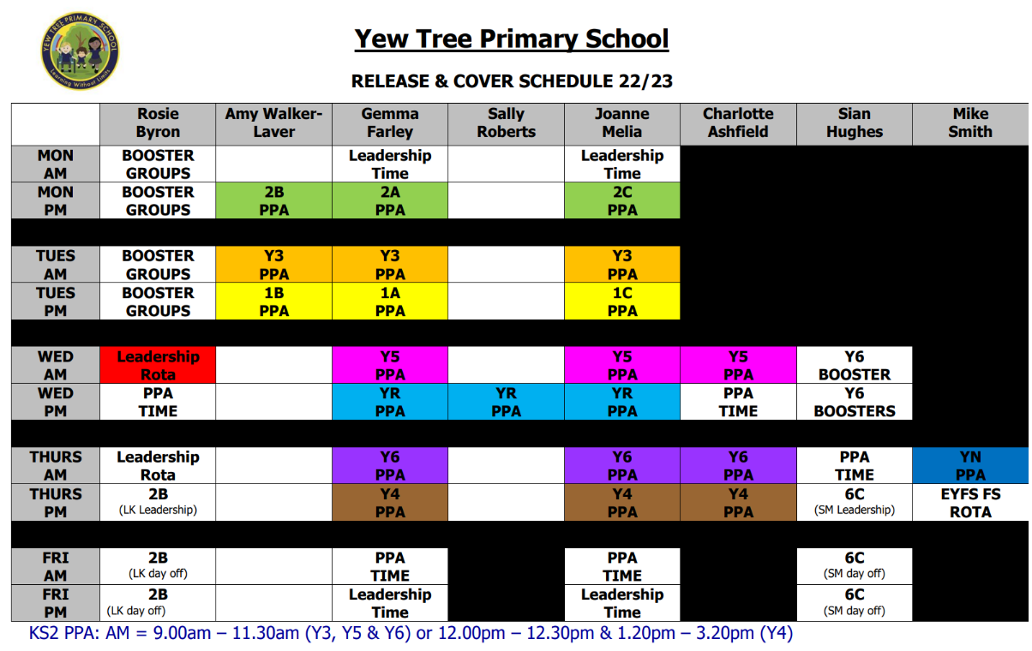
APPENDIX 2

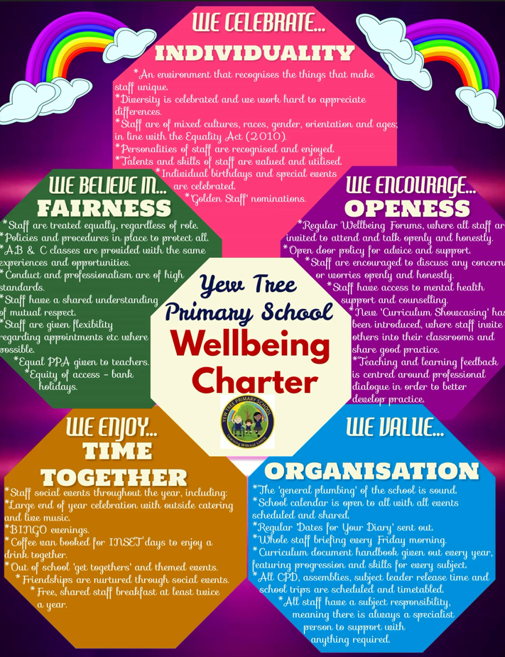
APPENDIX 3
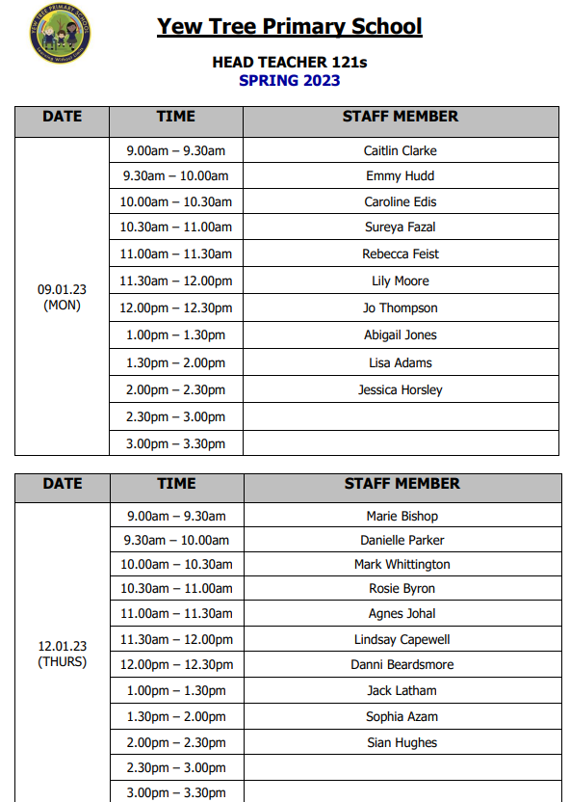
APPENDIX 4
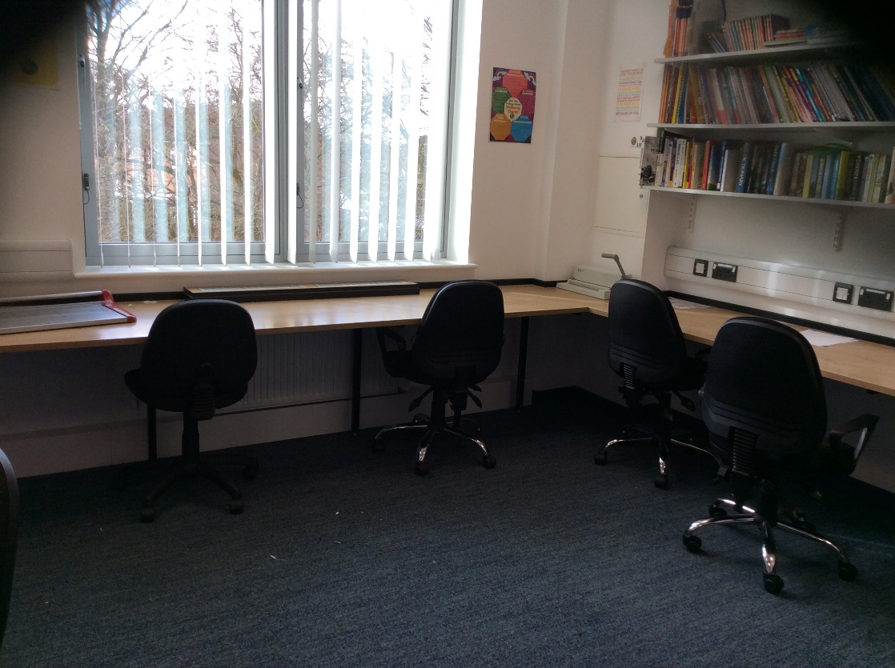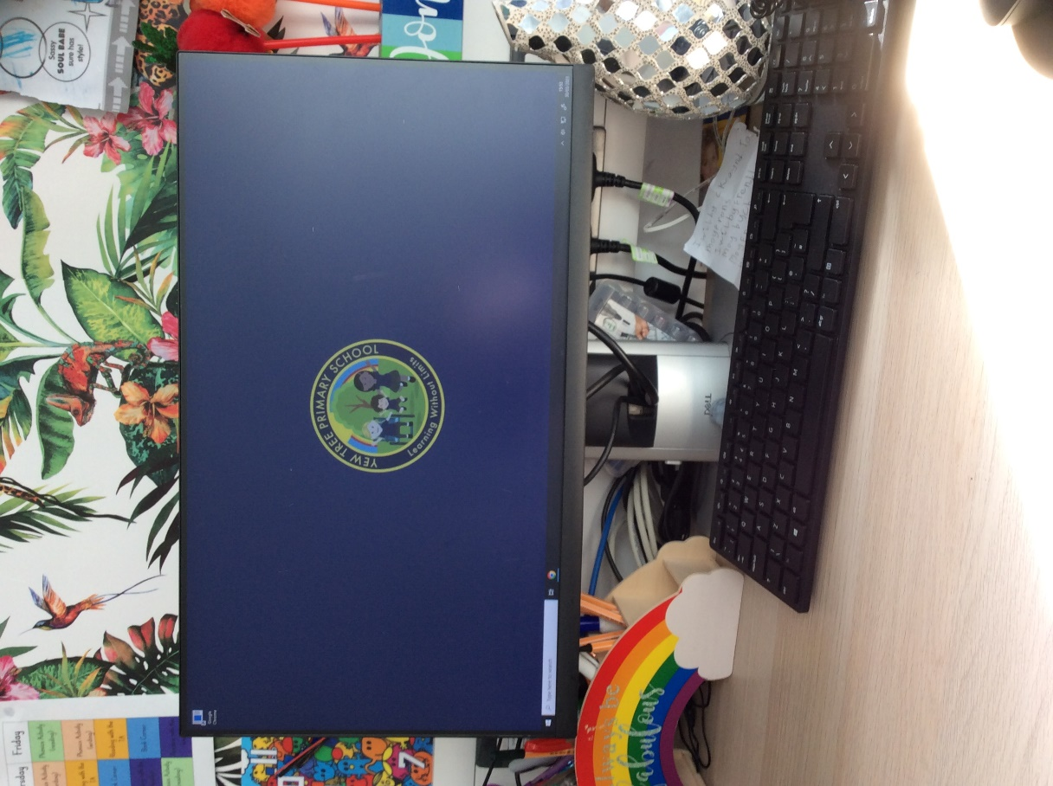
APPENDIX 5
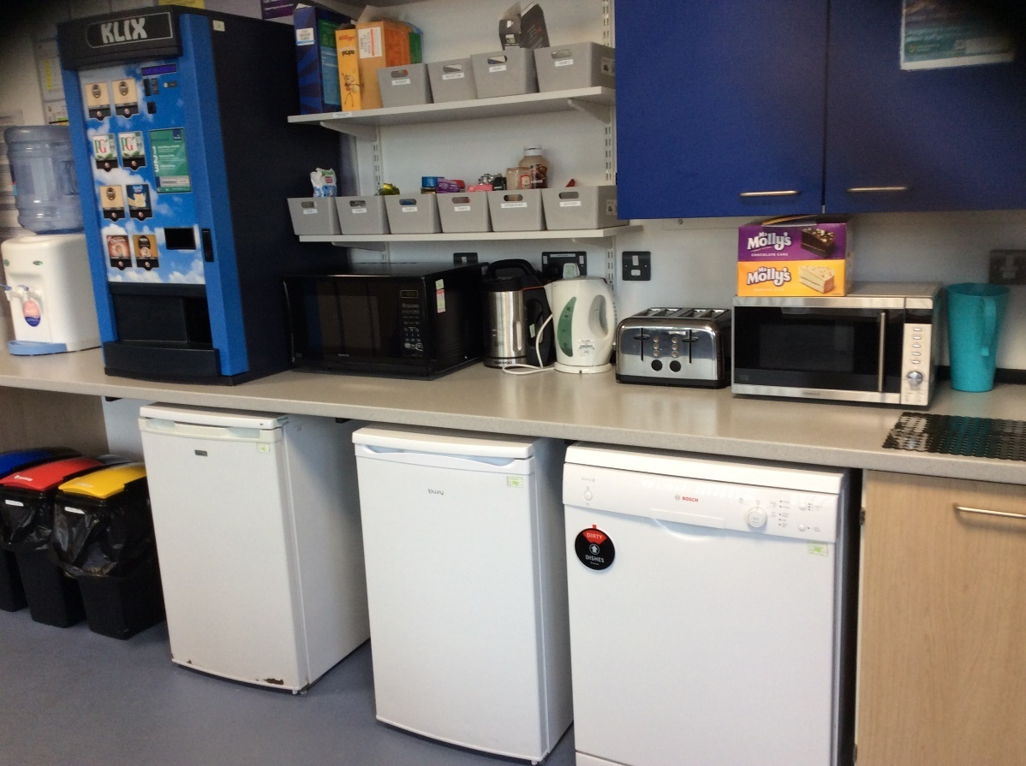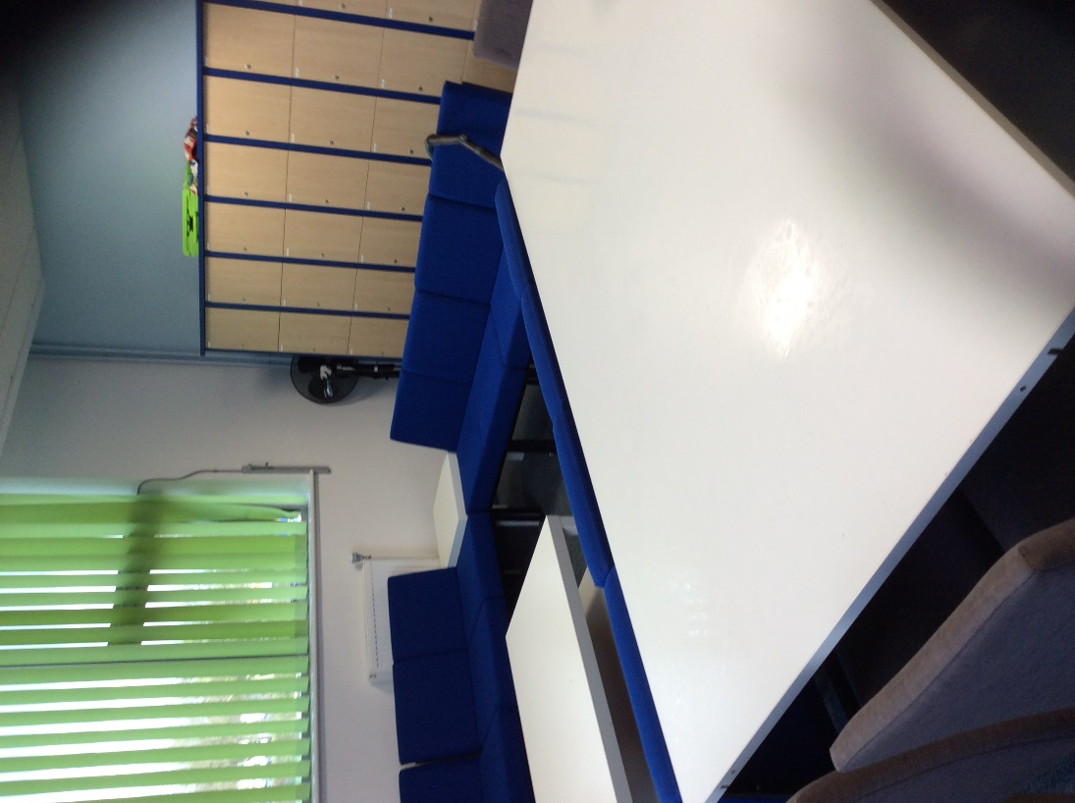

APPENDIX 6
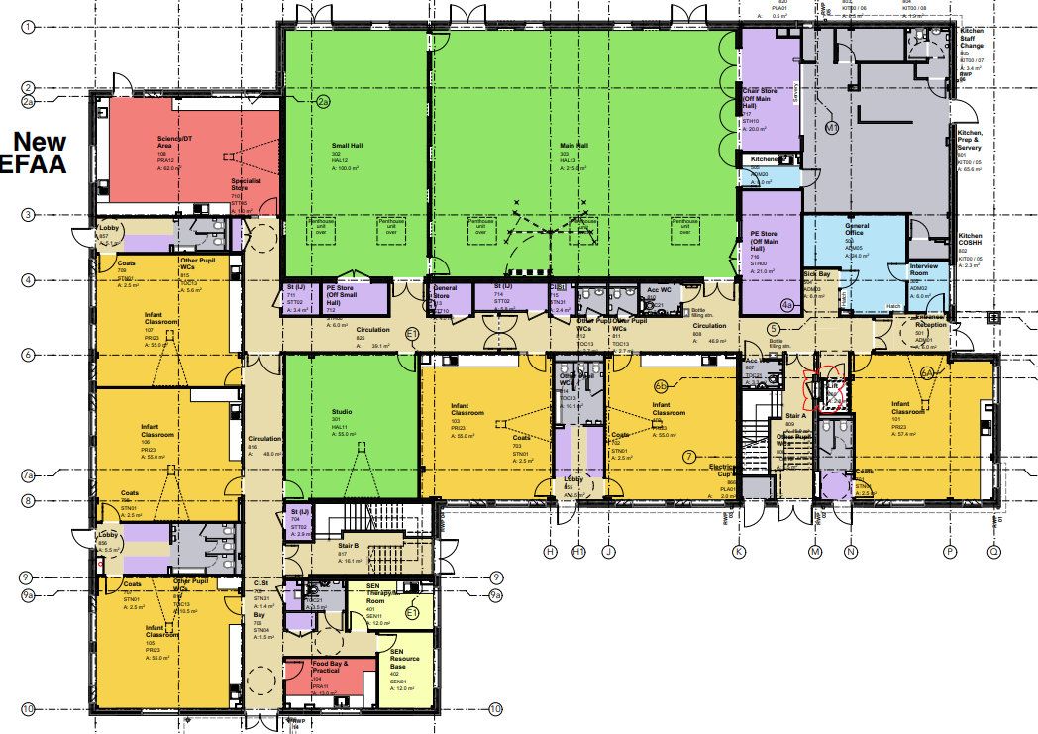
APPENDIX 7
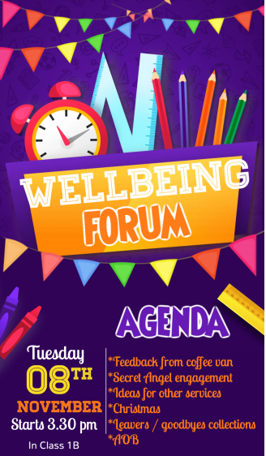
APPENDIX 8
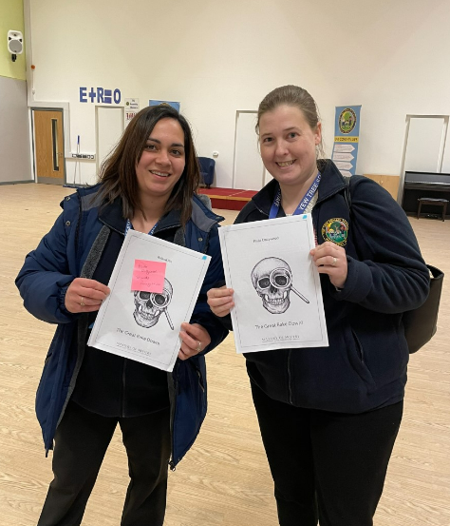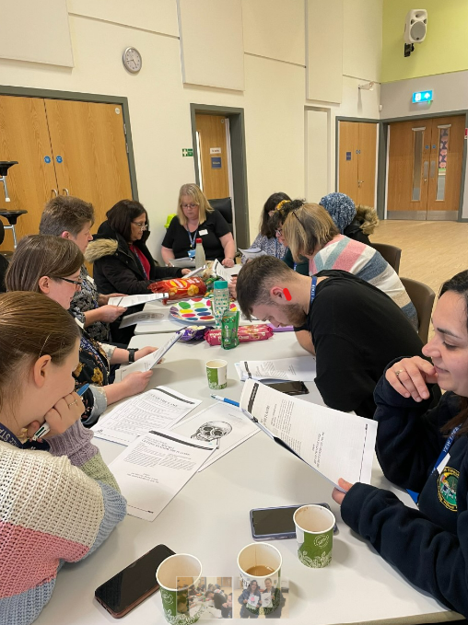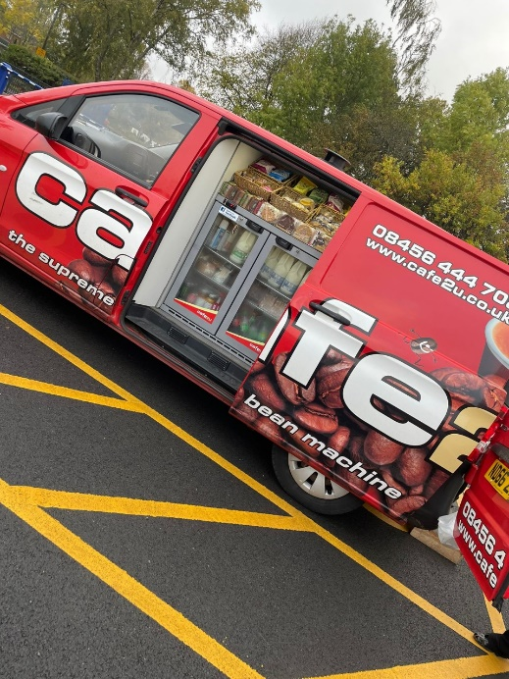

APPENDIX 9
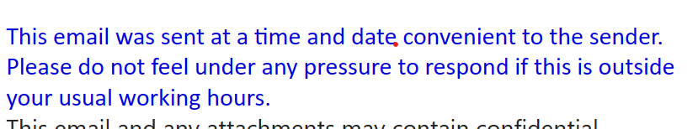

APPENDIX 10
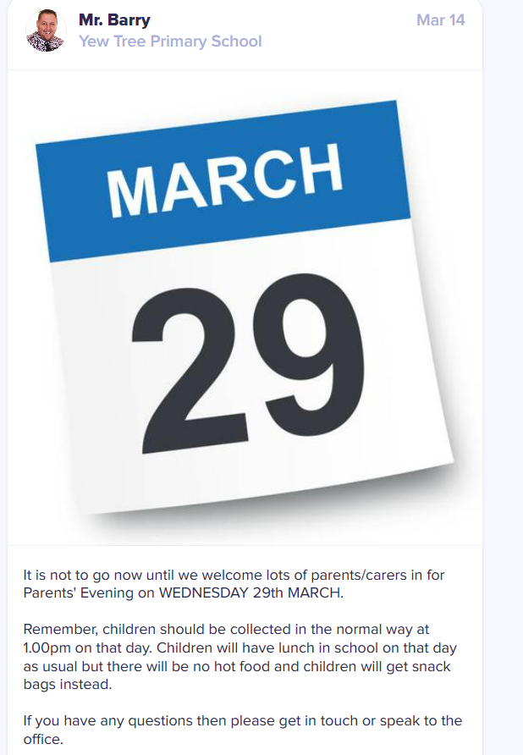
APPENDIX 11
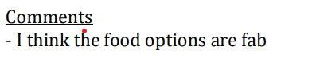

APPENDIX 12
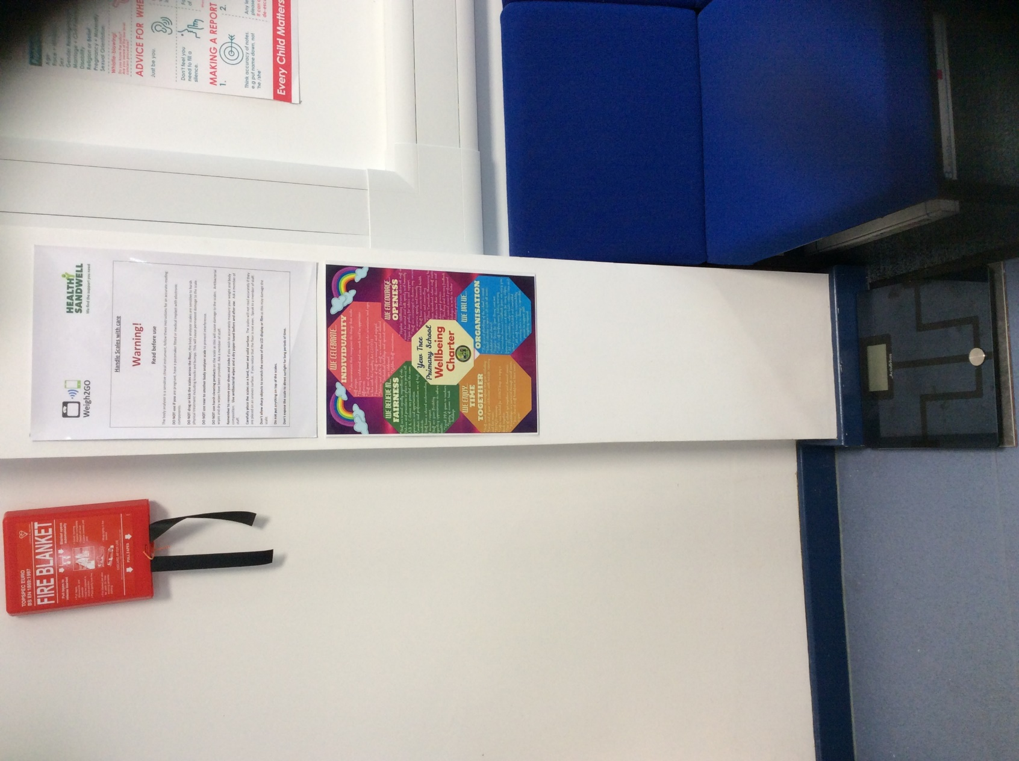
APPENDIX 13
